Lab: Docker Volume Creation & Data Persistence
A Docker volume is a persistent storage mechanism used to store data outside the container’s writable layer, so that data is not lost when the container is stopped, removed, or recreated.
🎯 Goal
Learn how to:
- Create a Docker volume
- Attach it to a container
- Add and validate persistent data
- Remove and recreate containers without losing data

🧩 STEP 1 — Verify Docker Setup
docker –version
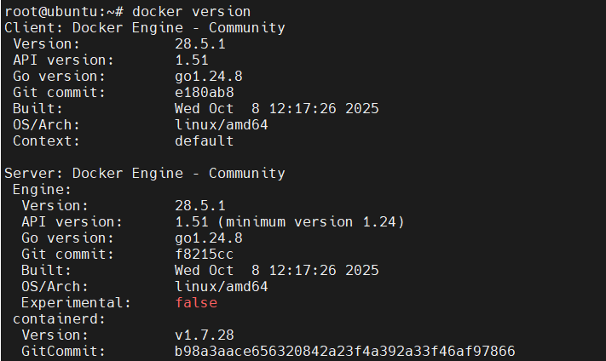
docker info
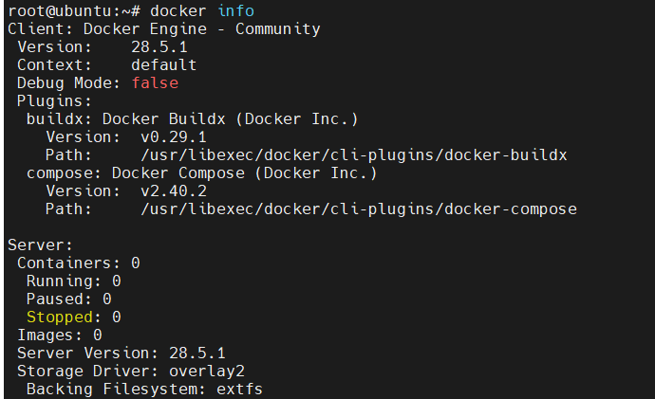
✅ Checkpoint: Ensure Docker daemon is running and you can run basic commands.

🧩 STEP 2 — Create a Docker Volume
docker volume create myvolume
List volumes:
docker volume ls
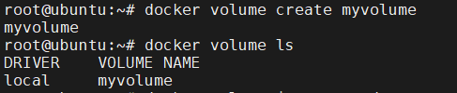
Inspect volume details:
docker volume inspect myvolume
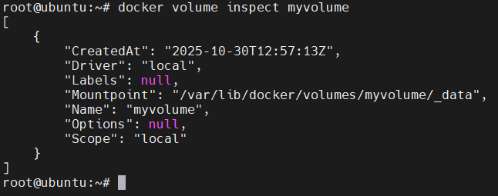
📘 Explanation: This creates a managed storage area (under /var/lib/docker/volumes/mydata/_data).

🧩 STEP 3 — Run a Container with the Volume and Port Mapping
Run an Nginx container and mount the volume:
docker run -d --name web1 -p 8080:80 -v mydata:/usr/share/nginx/html nginx
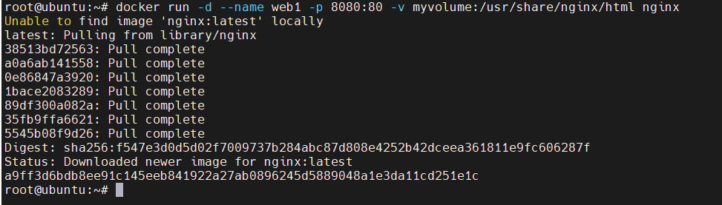
✅ Check running container:
docker ps

🧩 STEP 4 — Login to Container and Add Some Data
docker exec -it web1 /bin/bash
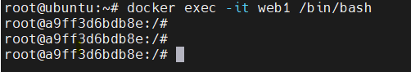
Inside the container:
cd /usr/share/nginx/html
echo "Hello from web1 at $(date)" > index.html
exit
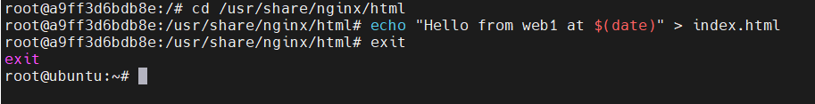

🧩 STEP 5 — Validate Data from Container
From the host, run:
curl http://localhost:8080
✅ You should see:
Hello from web1 at <timestamp>
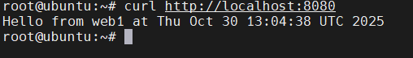

🧩 STEP 6 — Check Data in Volume (Optional)
Find volume mount point:
docker volume inspect mydata | grep Mountpoint
Example output:
"Mountpoint": "/var/lib/docker/volumes/mydata/_data"
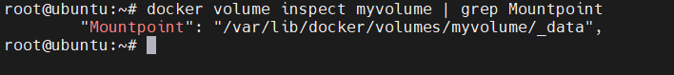
Check content directly on host:
cat /var/lib/docker/volumes/mydata/_data/index.html

🧩 STEP 7 — Delete the Container
docker rm -f web1
Check that volume still exists:
docker volume ls
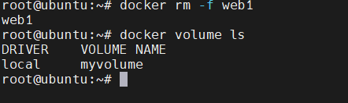
Inspect again:
docker volume inspect myvolume
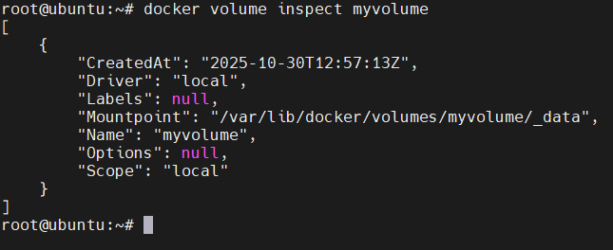
✅ Volume still remains even though the container was removed.

🧩 STEP 8 — Create Another Container with the Existing Volume
docker run -d --name web2 -p 8081:80 -v mydata:/usr/share/nginx/html nginx
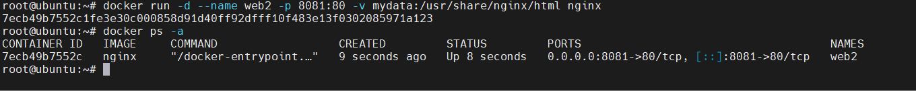
Now access the new container:
curl http://localhost:8081

✅ You should still see:
Hello from web1 at <timestamp>
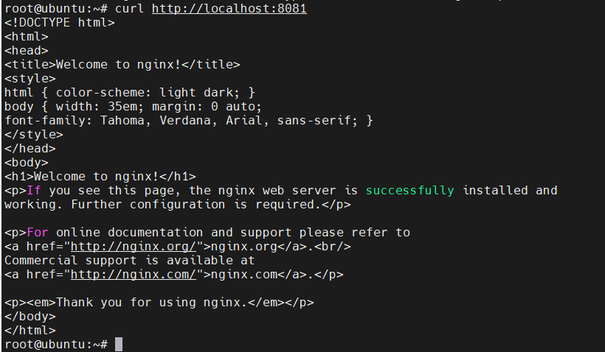
🎉 Success! The data persisted because it was stored in the Docker volume, not inside the container filesystem.

🧩 STEP 9 — Clean Up
When you’re done:
docker rm -f web2
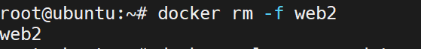
docker volume rm myvolume
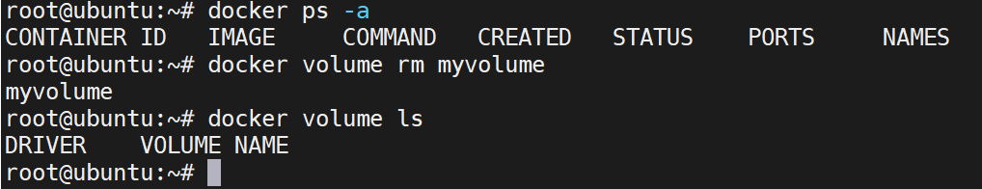

💡 Learning Points
- Containers are ephemeral — data inside them is lost when deleted.
- Docker volumes provide persistent storage beyond container lifetimes.
- Volumes can be shared across multiple containers.

